The Islamia University of Bahawalpur

Department of Information Technology


SOFTWARE DESIGN DESCRIPTION
(SDD DOCUMENT)

for

Chatbot for University FAQs

Version 1.0 By

M.MOHSIN UR REHMAN S23BINFT1M01003
Session Spring 2023 – 2027

Supervisor

DR.OMER RIYAZ

Table of Contents

Revision History I
1. Introduction 1
2. Design Methodology and Software Process Model 1
2.1 Design Methodology – Object-Oriented Programming (OOP) 1
2.2 Software Process Model – Incremental Development 2
Increment 1 2
Increment 3 2
Increment 4 2
3. System Overview 2
End User Responsibilities 3
3.1 Architectural Design 3
3.2.1 Admin Login Flow 3
3.2.2 FAQ Retrieval Flow 3
3.2.3 FAQ Management Flow 4
Architecture Diagram 5
Relationships Summary 5
4.5.1 Level 0 – Context Diagram 6
6.1 Admin.login(email, password) 8
6.2 FAQ.addFAQ(question, answer, category) 8
6.3 ChatbotEngine.processQuery(query) 8
6.4 FAQ.updateFAQ(faqId) 8
6.5 Feedback.saveFeedback() 9
8. Human Interface Design 9

Revision History

Name | Date | Reason for Changes | Version
M.MOHSIN UR REHMAN | JUNE 2026 | Initial Draft | 1.0

Application Evaluation History

Comments (by committee) *Include the ones given at scope time both in doc and presentation | Action Taken

Supervised by: DR.OMER RIYAZ Signature:

Introduction
The University FAQs Chatbot is a web-based intelligent chatbot system developed to provide automatic responses to frequently asked questions related to university information. The system uses Natural Language Processing techniques to understand user queries and retrieve accurate answers from a predefined FAQ database.
The chatbot helps students, faculty members, and visitors quickly access information regarding admissions, fee structure, departments, scholarships, examination schedules, hostel facilities, and other university services.
This Software Design Description (SDD) defines the complete design architecture, modules, data structures, workflows, algorithms, and implementation details of the University FAQs Chatbot.
The following modules are included in Version 1.0:
- Admin Authentication
- FAQ Management
- Query Processing
- FAQ Search and Retrieval
- NLP Processing Module
- User Feedback System
- Analytics and Logs
- Database Management
- Web Interface

Design Methodology and Software Process Model

Design Methodology – Object-Oriented Programming (OOP)
The system follows the Object-Oriented Programming (OOP) methodology because the chatbot system contains different entities such as Admin, User, FAQ, Feedback, QueryLog, and ChatbotEngine.
OOP Concepts Applied
Encapsulation
Each class stores its own attributes and methods. Example: FAQ class controls FAQ operations internally.

Inheritance

A base User class is extended by Admin.

Polymorphism

Different user roles use the same login() method but receive different dashboard permissions.

Abstraction

Database operations and NLP processing are abstracted from the frontend interface.

Software Process Model – Incremental Development
The Incremental Development Model is used for this project because:
- Core modules can be developed and tested separately.
- User feedback can be incorporated after each increment.
- High-priority features can be delivered early.
- Easier debugging and maintenance.
Planned Increments

Increment 1
- User Interface
- Admin Login
- Database Setup
Increment 2
- FAQ Management System
- Query Search System

Increment 3
- NLP Processing
- Chatbot Responses
- User Feedback

Increment 4
- Analytics Dashboard
- System Testing
- Deployment

System Overview
The University FAQs Chatbot is a standalone web application that allows users to ask questions in natural language and receive automated answers from a predefined FAQ database.
The system contains two main actors:
- Admin
- End User
Admin Responsibilities
- Manage FAQs
- View logs
- Monitor analytics
- Update chatbot content

End User Responsibilities
- Enter queries
- Receive chatbot responses
- Submit feedback

Architectural Design
The system follows a three-tier architecture.

Tier | Technology | Responsibility
Presentation Layer | HTML, CSS, JavaScript | User interface and chatbot interaction
Application Layer | Django (Python) | Business logic, NLP processing, FAQ retrieval
Data Layer | MySQL Database | FAQ storage, logs, feedback, admin data

The major subsystems and their interconnections:

Subsystem | Description | Communicates With
Authentication Module | Handles admin login and security | Database
FAQ Management Module | Add, edit, delete FAQs | MySQL
Query Processing Module | Processes user input queries | NLP Engine
NLP Module | Matches queries with FAQs | Database
Feedback Module | Stores user feedback | Database
Analytics Module | Maintains logs and statistics | Database

3.2 Process Flow Descriptions

3.2.1 Admin Login Flow
- Admin opens login page.
- Admin enters email and password.
- System validates credentials.
- If valid → redirect to Admin Dashboard.
- If invalid → show error message.

3.2.2 FAQ Retrieval Flow
- User enters query.
- NLP module processes query.
- System searches FAQ database.
- Most relevant answer is retrieved.
- Response displayed to user.
- Query stored in logs.

3.2.3 FAQ Management Flow
- Admin opens dashboard.
- Admin selects Add/Edit/Delete FAQ.
- System updates database.
- Updated FAQs become available instantly

Architecture Diagram

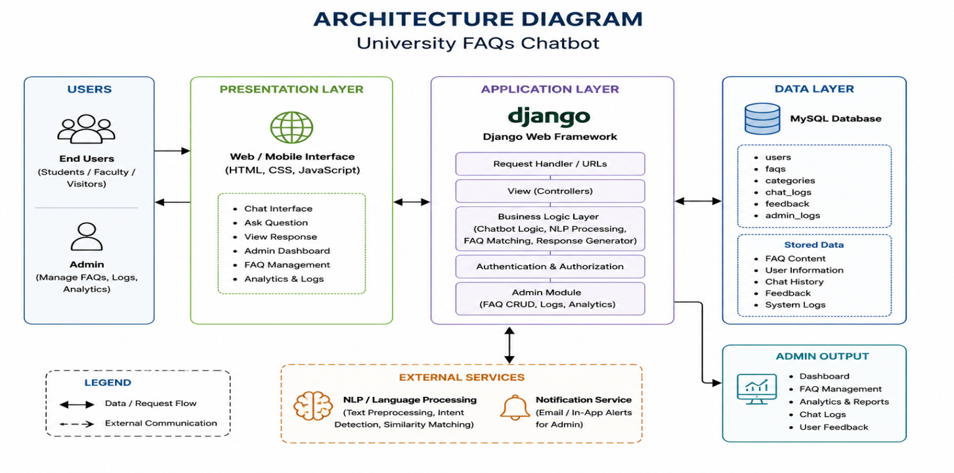
- Design Models
The system is designed using OOP principles.

  - Class Diagram

Relationships Summary
- User → Admin : Inheritance
- FAQ ↔ ChatbotEngine : Association
- User ↔ Feedback : Association
- User ↔ QueryLog : Association
Class Details
Class | Attributes | Methods
User | userId, name, email | askQuery(), giveFeedback()
Admin | adminId, password | login(), manageFAQ(), viewLogs()
FAQ | faqId, question, answer, category | addFAQ(), updateFAQ(), deleteFAQ()
ChatbotEngine | engineId | processQuery(), retrieveAnswer()
Feedback | feedbackId, message, rating | saveFeedback()
QueryLog | logId, query, timestamp | saveLog(), generateReport()

4.2 Sequence Diagrams
Step | From | To | Message / Action
1 | User | Chatbot UI | Enter query
2 | Chatbot UI | ChatbotEngine | processQuery(query)
3 | ChatbotEngine | NLP Module | analyzeQuery()
4 | NLP Module | Database | searchFAQs()
5 | Database | NLP Module | return matched FAQ
6 | NLP Module | ChatbotEngine | return answer
7 | ChatbotEngine | User | display answer

4.2.2 Sequence – Admin Login

Step | From | To | Message / Action
1 | Admin | Login Page | enter credentials
2 | Login Page | Authentication Module | validate login
3 | Authentication Module | Database | verify credentials
4 | Database | Authentication Module | success/failure
5 | Authentication Module | Admin | open dashboard

4.3 State Transition Diagram – Query Processing

State | Description | Trigger
Idle | Waiting for user input | User opens chatbot
Processing | NLP analyzing query | Query submitted
Searching | Database searching FAQs | NLP request
Responding | Answer displayed | FAQ found
Error | No result found | Query mismatch

4.4 ER Diagram – Entity Relationship Description

Entity | Primary Key | Fields | Relationships
users | userId | name, email | One user can submit many queries
admins | adminId | email, password | Manages FAQs
FAQs | faqId | question, answer, category | Used by chatbot
feedback | feedbackId | rating, message | Linked with users
logs | logId | query, timestamp | Stores all queries

4.5 Data Flow Diagram (DFD)

4.5.1 Level 0 – Context Diagram
External entities:
- User
- Admin
Inputs:
- User queries
- Admin credentials
- FAQ updates
Outputs:
- Chatbot responses
- Logs
- Reports

4.5.2 Level 1 – Major Processes

Process No. | Process Name | Inputs | Outputs | Data Store
P1 | Admin Authentication | Email, Password | Admin Session | DS1: Admin
P2 | Query Processing | User Query | Processed Query | DS2: Logs
P3 | FAQ Retrieval | Query | Answer | DS3: FAQs
P4 | FAQ Management | FAQ Data | Updated FAQs | DS3: FAQs
P5 | Feedback Management | User Feedback | Feedback Report | DS4: Feedback

5. Data Design
The system uses MySQL as the database management system.
The database stores:
- FAQs
- Admin accounts
- Query logs
- Feedback records
- User sessions
5.1 Data Dictionary

Field / Entity | Type | Table | Description
adminId | Integer | admins | Unique FAQ identifier
answer | Text | faqs | FAQ answer
category | String | faqs | category
email | Text | admins | Admin email
faqId | Text | faqs | Unique FAQ identifier
feedbackId | Text | feedback | Unique feedback ID
message | Text | feedback | User feedback message
password | String | admins | Encrypted password
query | Text | logs | User query
question | Text | faqs | FAQ question
rating | Integer | feedback | User rating
timestamp | DateTime | logs | Query timestamp
userId | Integer | users | Unique user ID

6. Algorithm & Implementation

6.1 Admin.login(email, password)
- INPUT: email, password
- VALIDATE email format
- SEARCH admin record in database
- IF credentials invalid → RETURN error
- CREATE session
- REDIRECT to dashboard
- RETURN success

6.2 FAQ.addFAQ(question, answer, category)
- INPUT: question, answer, category
- VALIDATE fields are not empty
- INSERT FAQ into database
- RETURN success message

6.3 ChatbotEngine.processQuery(query)
- INPUT: user query
- CLEAN query text
- REMOVE stop words
- APPLY NLP matching
- SEARCH FAQ database
- IF match found → RETURN answer
- ELSE → RETURN fallback response

6.4 FAQ.updateFAQ(faqId)
- FETCH FAQ from database
- UPDATE question/answer/category
- SAVE changes
- RETURN success message

6.5 Feedback.saveFeedback()
- INPUT: rating, message
- STORE feedback in database
- UPDATE analytics
- RETURN confirmation

7. Software Requirements Traceability Matrix

Req. No. | Requirement Name | Design Component | Component Items
FR-1 | Admin Login | Class Diagram, Algorithm | Admin.login()
FR-2 | Manage FAQs | FAQ Class, DFD | addFAQ(), updateFAQ(), deleteFAQ()
FR-3 | Retrieve Answer | NLP Module | processQuery()
FR-4 | Search FAQ | Sequence Diagram | FAQ Retrieval Flow
FR-5 | User Feedback | Feedback Module | saveFeedback()

8. Human Interface Design

Screen | Description | Key Actions
Home Page | Main chatbot interface | Start chatbot
Chat Window | User interacts with chatbot | Ask query
Search Results | Displays chatbot answer | View

8.1 Home page

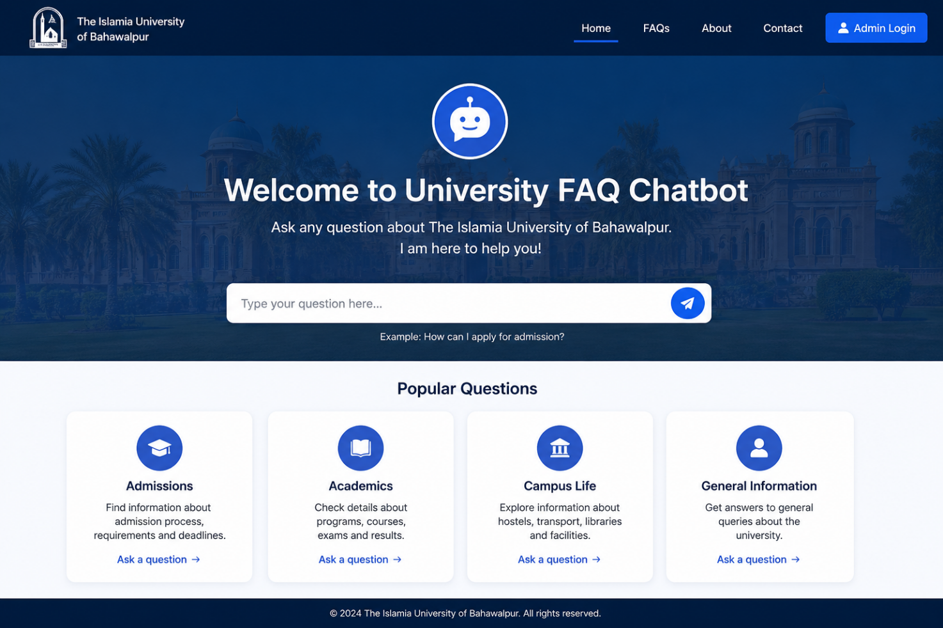

8.2 Chat window and Search Results

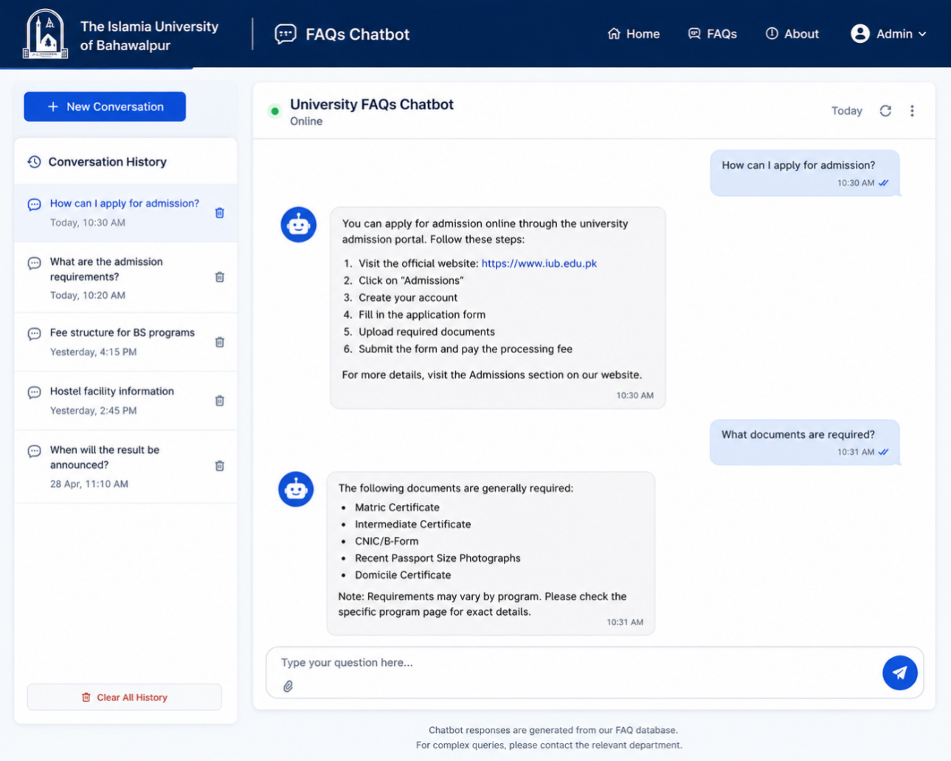

8.3 Ratting and feedback

